MATHEMATICS LECTURES BY
MANISH KALIA
(B.TECH Delhi College of Engineering)

ellipse

An ellipse is the set of all points in
a plane, the sum of whose distances from two
fixed points in the plane is a constant
The two fixed points are called the foci (plural
of ‘focus’) of the ellipse
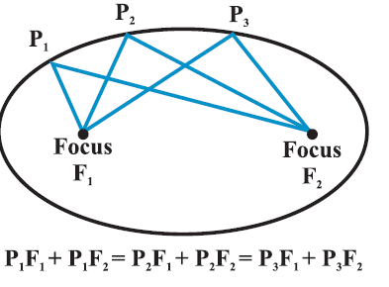
Terms related to elipse

Centre:The mid point of the line segment joining the foci is called the centre of theellipse.
Major and Minor Axis:The line segment through the foci of the ellipse is called the major axis and the line segment through the centre and perpendicular to the major axis is called the minor axis.
Vertices The end points of the major axis are called the vertices of the ellipse
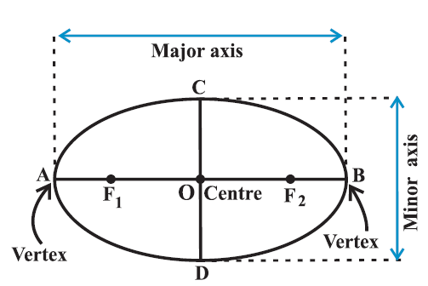
Relationship between semi-major axis, semi-minor axis and the distance of the focus from the centre of the ellipse

Take a point P at one end of the major axis.
Sum of the distances of the point P to the foci is

FP + GP = FO + OP +GP

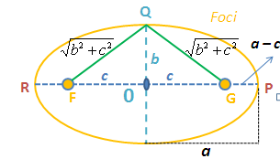
Take a point Q at one end of the minor axis.
Sum of the distances from the point Q to the foci is
FQ + GQ =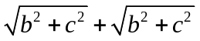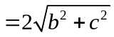
Since both P and Q lies on the ellipse. By the definition of ellipse, we have
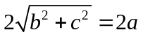or 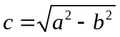

Eccentricity
The eccentricity of an ellipse is the ratio of the distances from the centre of the ellipse to one of the foci and to one of the vertices of the ellipse (eccentricity is
denoted by e) i.e., e=c/a
Then since the focus is at a distance of c from the centre, in terms of the eccentricity the focus is at a distance of ae from the centre.
Standard equations of an ellipse

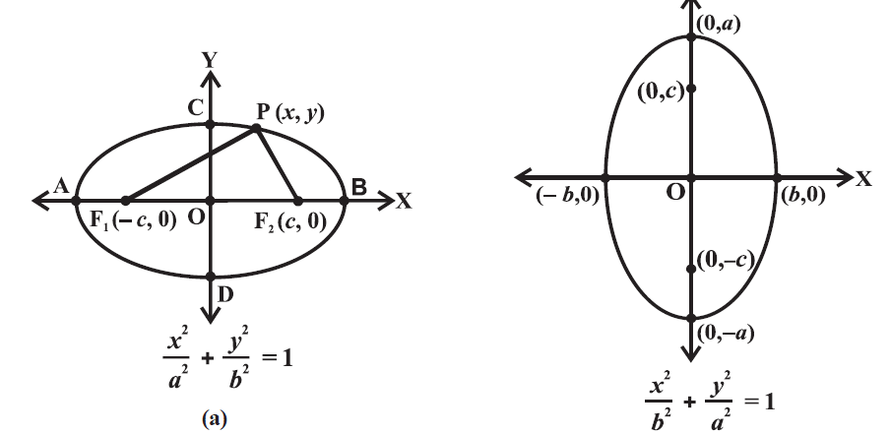
Latus rectum
Latus rectum of an ellipse is a line segment perpendicular to the major axis through any of the foci and whose end points lie on the ellipse
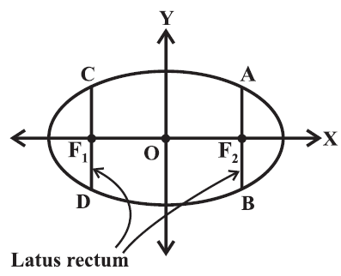
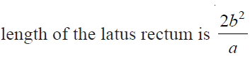

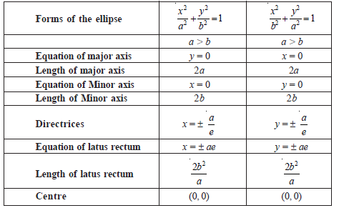
For JEE Mains & advanced
Definition:If a point moves in a plane in such a way that ratio of
its distances from a fixed point (focus) and a fixed straight line (directrix) is always less than 1, i.e. e < 1 called an ellipse
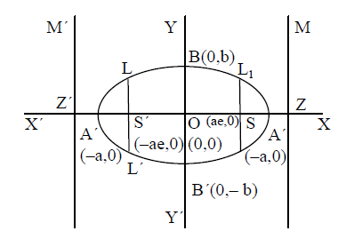

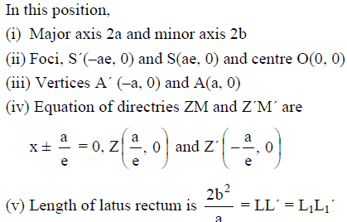

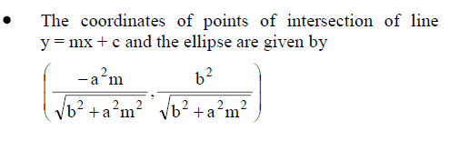
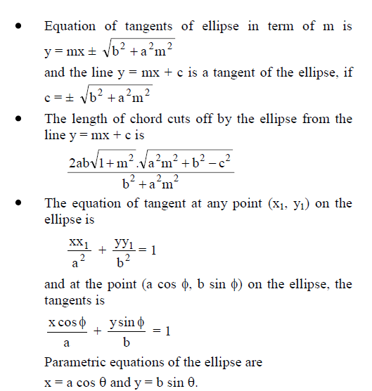
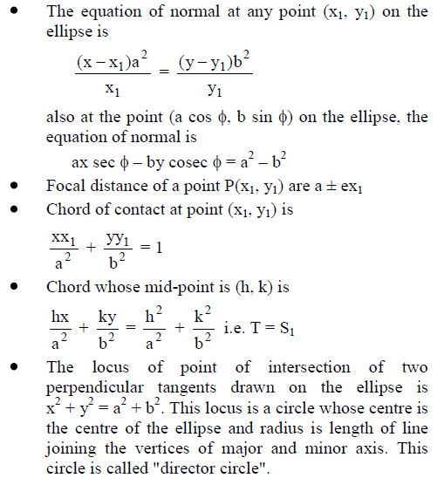
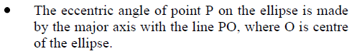

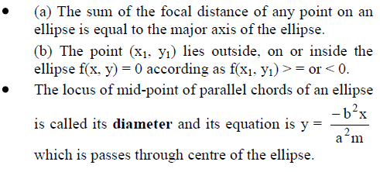
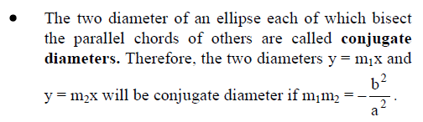

 Exercise1(NCERT)
Q1 Find the coordinates of the foci, the vertices, the length of major axis, the minor axis, the eccentricity and the latus rectum of the ellipse
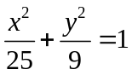
Q2 Find the coordinates of the foci, the vertices, the lengths of major and minor axes and the eccentricity of the ellipse 9x² + 4y² = 36.

Q3 Find the equation of the ellipse whose vertices are (±13, 0) and foci are (± 5, 0).

Q4 Find the equation of the ellipse, with major axis along the x-axis and passing through the points (4, 3) and (– 1,4).

Answers
1 | Foci (– 4,0) and (4,0), vertices (– 5, 0) and  (5, 0) major axis 10 units,minor axis 6 units, eccentricity is 4/5, latus rectum 18/5
2 | Foci (0,√5) and (0,-√5), vertices ( 0,3) and(0,-3) major axis 6 units,minor axis 4 units,eccentricity is √5/3.
3 | 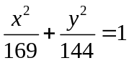 | 4 | 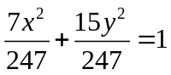

 Exercise2
Q1 Find the equation of the elipse whose foci are (2,3) ,(-2,3) and whose semi minor axis is √5
Q2 Find the equation of ellipse the extremities of whose minor axis are (3,1) and (3,5) and whose eccentricity is 1/2
Q3 Find the equation of ellipse having tha major and minor axes along x and y axes respectively,the distance between whose foci is 8 units and the distance between the directrices is 18 units
Q4 find the equation of ellipse that passes through the origin and has the foci at the points (-1,1) and (1,1)
Q5 A rod of length 12 cm moves with its ends always touching the co-ordinate axes.Determine the equation of the locus of a point on the rod ,which is 3 cm from the end in contact with the x axis
Q6 An arc way is in the shape of of semi ellipse ,the road level being the major axis .If the breadth of the arc way is 30 feet and a man 6 feet tall just touches the top when 2 feet from the side,find the greatest height of the arch.

Q7 Find the equation of the ellipse whose major and minor axes lie along the lines x − 3y + 3 = 0 and 3x + y −1 = 0 and whose lengths are 6 and 2 6 respectively.

Answers
1 | 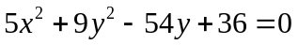
2 | 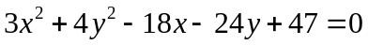
3 | 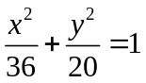 | 4 | 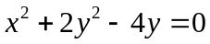
5 | 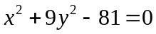 | 6 | 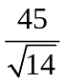
7 | 21x² − 6xy + 29y² + 6x − 58y −151 = 0

 Exercise3(objective for JEE-Mains & Advanced)
Q1 If the latus rectumof the ellipse is half of its major axis ,its eccentricity is
- ¾ b) ¼ c) ½ d) 3/2
Q2 The centre of the ellipse 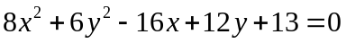 is at
- (1,1) b)(-1,1) c)(1,-1) d) none of these
Q3 The length of the latus rectum of an ellipse is one third of the major axis,its eccentricity would be :
- 2/3 b)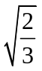 c)1/√3 d)1/√2
Q4 The latus rectum of the ellipse 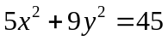is
- 5/3 b)10/3 c)2√5/3 d)√5/3
Q5 The radius of the circle passing through the foci of the ellipse 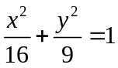,having its centre at (0,3) is
- 4 b)3 c)1/√2 d) 7/2
Q6 The eccentricity of an ellipse,with its centre at the origin is ½ .If one of the directrices is x=4,then the equation of the ellipse is [AIEEE-2004]
- 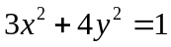 b) 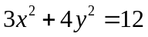
c) 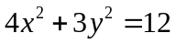 d) 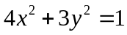
Q7 An ellipse has OB as semi minor axis ,F and F’ its foci and the angle FBF’ is right angle .Then the eccentricity of ellipse is [AIEEE-2005]
- ¼ b)1/√3 c)1/√2 d) ½
Q8 A focus of an ellipse is at the origin .The directrix s the line x=4 and the eccentricity is 1/2 ,then the length of the semi major axis is [AIEEE-2006]
- 4/3 b)5/3 c)8/3 d)2/3
Q9 If P(x,y) ,F1=(3,0) and F2=(-3,0) and 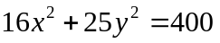,then PF1+PF2 equals
[IIT-1998]
- 8 b) 6 c)10 d)12
Q10 The number of values of c such that the line y=4x+c touches the curve 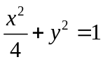 is
[IIT-1998]
- 0 b)2 c)1 d) infinite

Answers
1 | a | 2 | c | 3 | b | 4 | b | 5 | a | 6 | b
7 | c | 8 | c | 9 | c | 10 | b

